Bay area 8.02SP3 HIUI upgrade instructions

We need to backup the copy of cacert ( it is under java\lib\security)

Global

* CD to MongoDB bin directory where mongodump.exe is located
* mongodump.exe --host "localhost:27017" --out dump\global
* This command will create a new folder in the bin directory, modify the --out path if you wish to have the dump saved elsewhere

Tenant

* CD to MongoDB bin directory where mongodump.exe is located
* mongodump.exe --host "localhost:27018" --username admin --password <password> --out dump\tenant
* This command will create a new folder in the bin directory, modify the --out path if you wish to have the dump saved elsewhere

​

<password> should be the tenant password

a

Artifactory connection should be established and download the chef and install

Edit the 8.03_base Jason fille

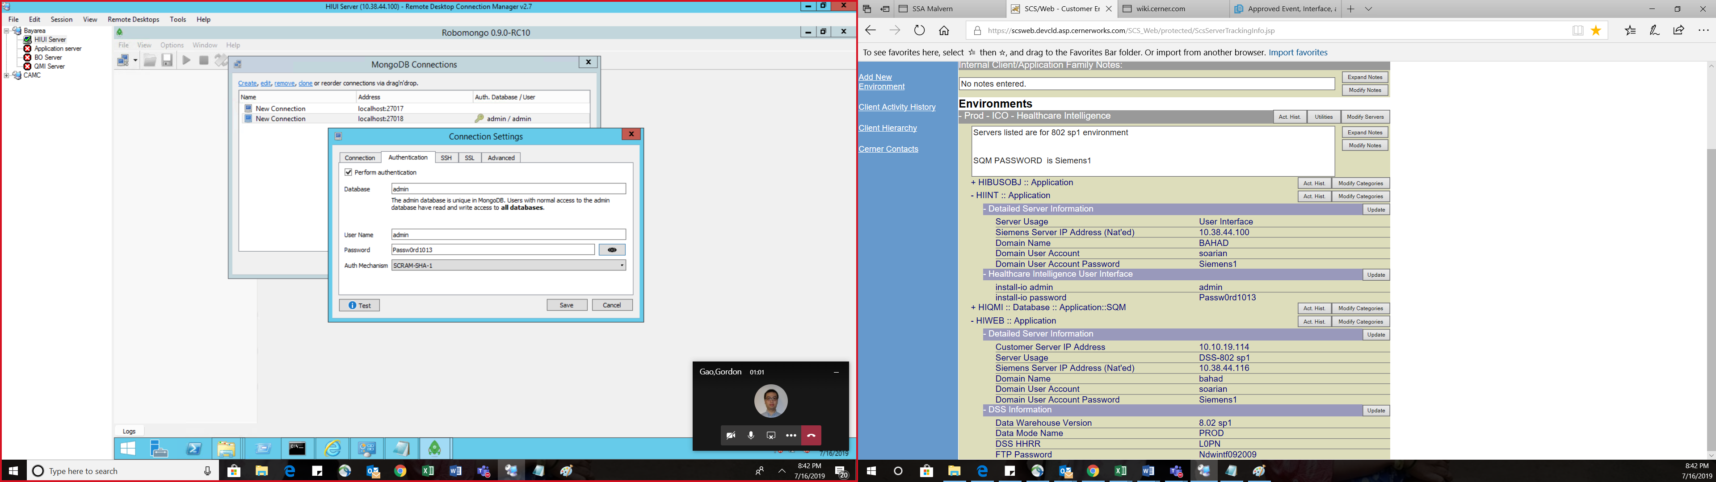

I had to do the below step as mongo is higher than the version specified

# [6125] MongoDB Uninstall for version less than 3.6

This section is required during an upgrade to MongoDB 3.6 on a HIUI Integrated Server. It is to be performed before running Chef scripts and only if a MongoDB version less than 3.6 is present **and** is not MongoDB 3.4.4 2008R2Plus Enterprise (64 bit).

* 1. Connect to the HIUI Integrated Server.
  2. Open “Prgrams and Features” and verify the version of MongoDB that is installed:
     + If version is **MongoDB 3.4.4 2008R2Plus Enterprise (64 bit)** then do not proceed with the remaining steps in this section.
     + If any version other than **MongoDB 3.4.4 2008R2Plus Enterprise (64 bit)** is installed, continue to step 3.
  3. Open ‘Services’ and stop the below mentioned services:
     + MongoDB global
     + MongoDB tenant
  4. Delete the above mentioned services by using the below mentioned commands in Windows Command Prompt:
     + sc delete mongodb-global
     + sc delete mongodb-tenant

Uninstall the MongoDB software that is installed in this server from ‘Programs and Features’

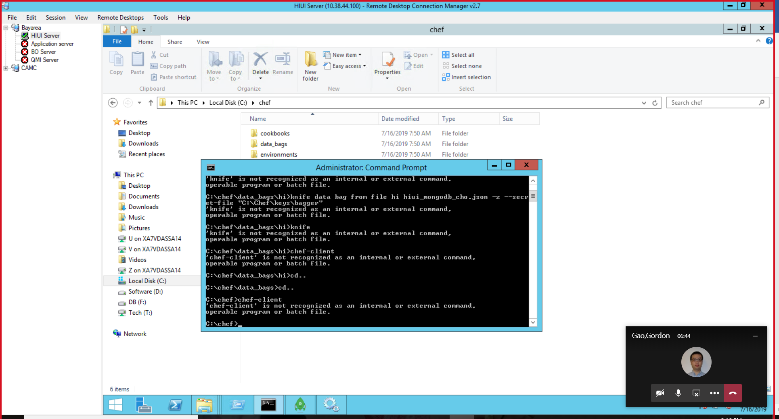

Knife was not working properly, checked the chef install, it looks good, path was added it needed a reboot.

Issue resolved

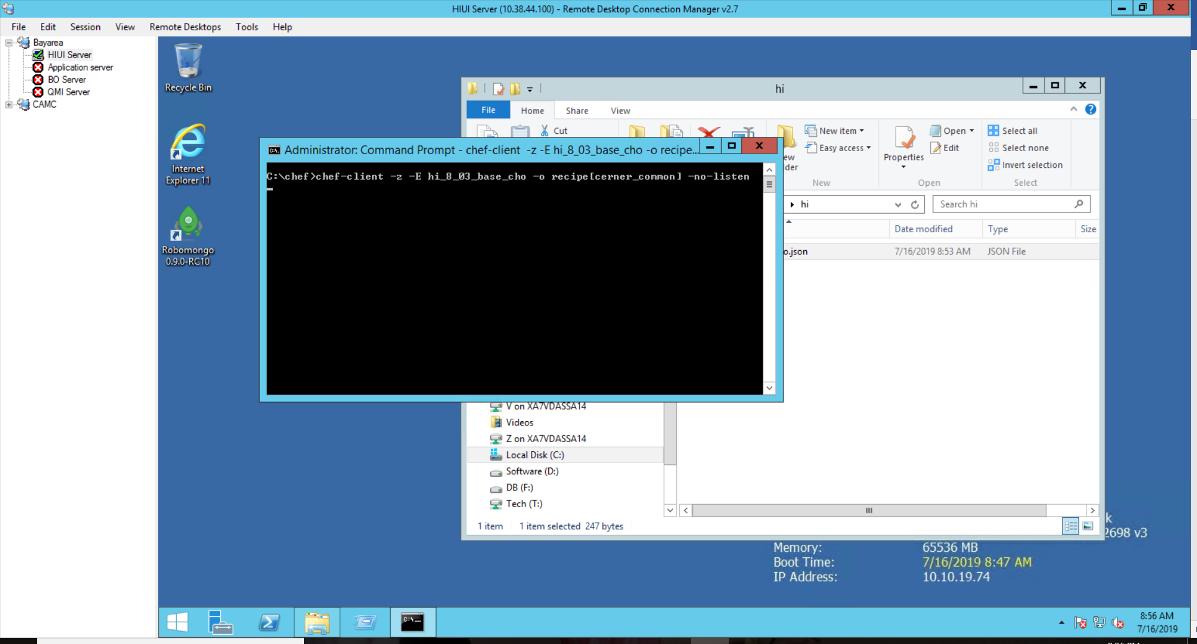Cerner common is installed using above command

Got an issue

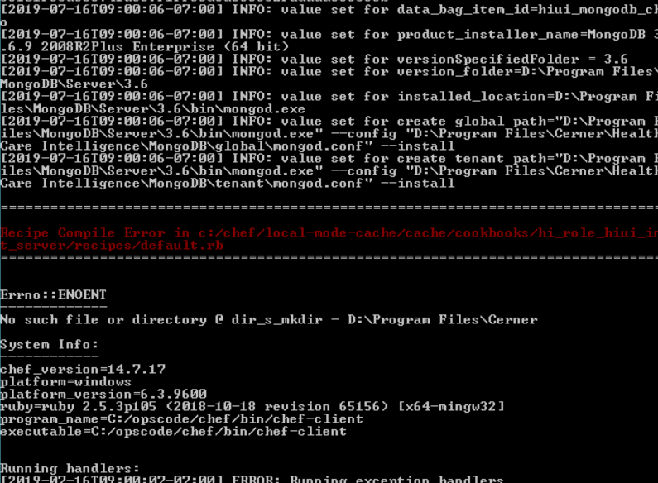

The drive letter changed to C drive and issue resolved

Got one more issue as below.

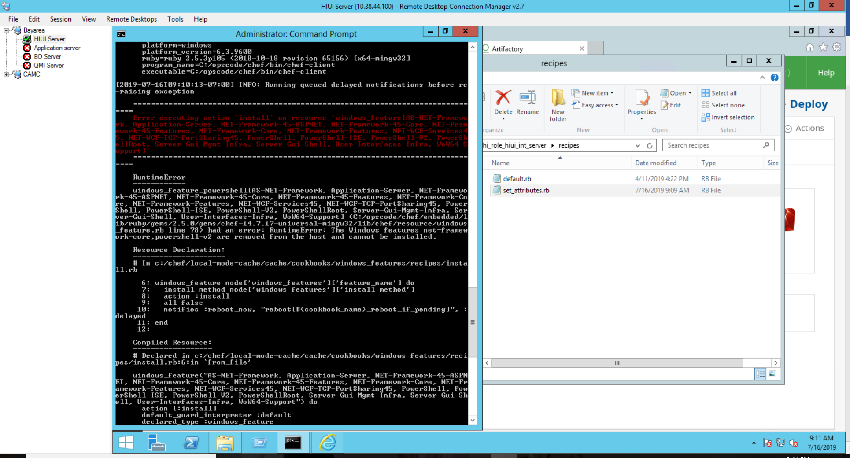

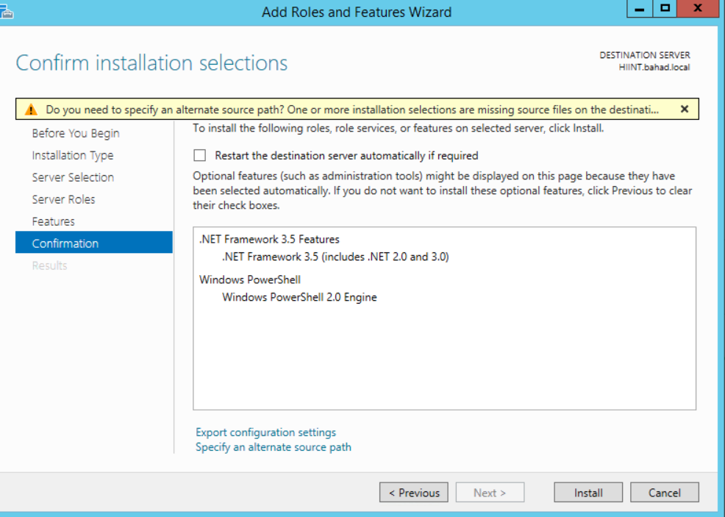

Resolution: client installed dotnet and powershell, rest doesn’t need sxs media

Below are the features which get installed

Application-Server',

NET-Framework-45-ASPNET',

NET-Framework-45-Core',

NET-Framework-45-Features',

NET-Framework-Core',

NET-Framework-Features',

NET-WCF-Services45',

NET-WCF-TCP-PortSharing45',

PowerShell',

PowerShell-ISE',

PowerShell-V2',

PowerShellRoot',

Server-Gui-Mgmt-Infra',

Server-Gui-Shell',

User-Interfaces-Infra',

WoW64-Support']

**1st Reboot happened at 11:07 my time ( sleepless)**

The chef script got completed

The install io has been completed

The values were auto populated

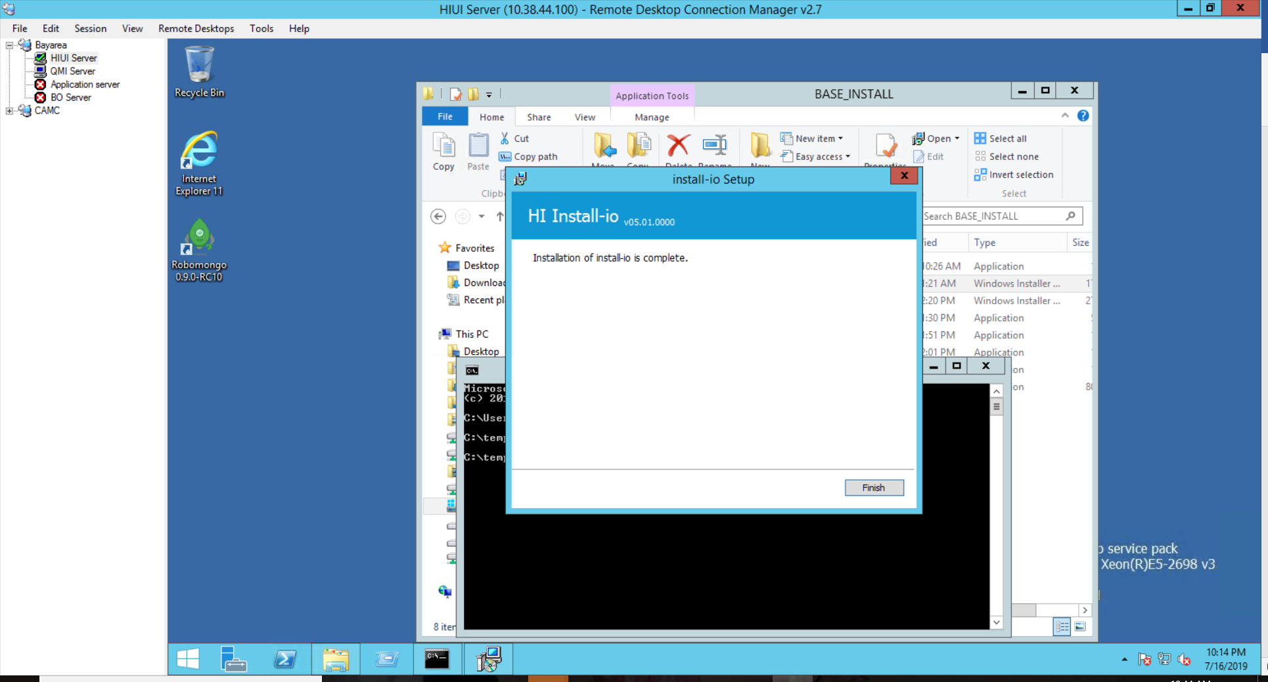

SQM install done

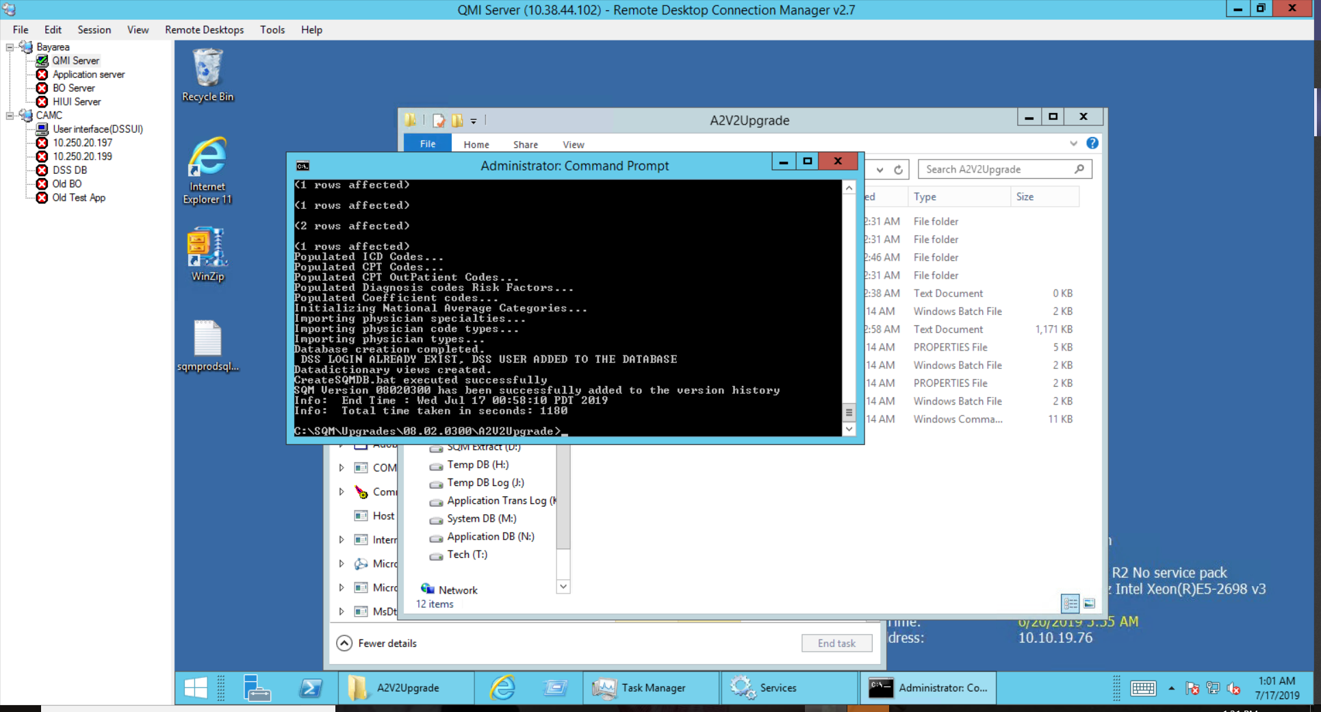

HIUI is not progressing, got an issue

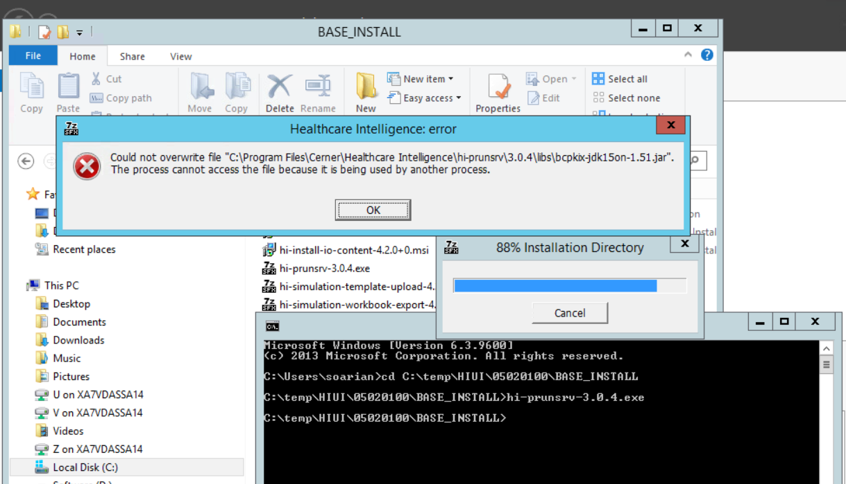

**Installed the global and tenant using below commands**

mongod --config "F:\Program Files\Cerner\Healthcare Intelligence\MongoDB\global\mongod.conf" -install

mongod --config "F:\Program Files\Cerner\Healthcare Intelligence\MongoDB\tenant\mongod.conf" -install

**copied the dump folder which was taken as backup before to the new mongo version bin folder**

**Restored the DB from dump using below commands**

Complete databases were gon, good that I had taken backup before starting the upgrade

* CD to MongoDB bin directory where mongorestore.exe is located
* mongorestore.exe --host "localhost:27017" dump\global
* This command will restore from global folder in the bin\dump directory if it exists, modify the path if you are restoring from a dump folder elsewhere

Tenant

* CD to MongoDB bin directory where mongorestore.exe is located
* mongorestore.exe --host "localhost:27018" --username admin --password <password> dump\tenant
* This command will restore from tenant folder in the bin\dump directory if it exists, modify the path if you are restoring from a dump folder elsewhere